BASH – Fix The Display and Console Gibberish on a Linux / Unix / OS X / BSD Systems
by VIVEK GITE on AUGUST 8, 2006 last updated DECEMBER 9, 2014
in LINUX, REDHAT/FEDORA LINUX, SHELL SCRIPTING, SUSE LINUX, SYS ADMIN, TIPS,TROUBLESHOOTING, UBUNTU LINUX, UNIX
Sometime my R & D result into weird output on screen. For example, accidentally I run cat command over binary file – cat /sbin/*. You will be not able to access your bash/ksh/zsh based terminal. It will be full of wired character sequences that can lock down your display. These characters will hide what you type or character displayed into strange symbols. To clear gibberish all over the screen use the following method.

Method #1: Fixing the display
Here is my console with gibberish all over the screen:
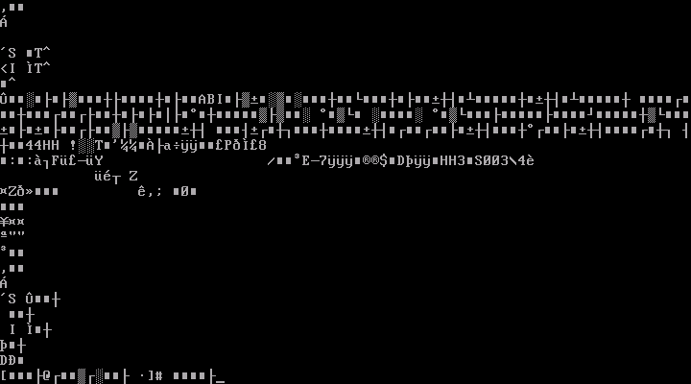
Fig.01: Bash fix the display
To fix the display just type the reset command. It will initialization terminal again for you:
$ reset
If reset command failed to work type the following command to restore the session to a normal state:
$ stty sane
Press CTRL + L to clear the screen (or type clear command):
$ clear

Method #2: Use ANSI escape sequence
Another option is to type the following ANSI escape sequence:
echo -e "\033c"
Sample outputs from both commands:
Animated gif 01: Fix Unix Console Gibberish Command Demo

